Botball Lesson Plan

**Title:** Moving the robot in a straight line

**Concept / Topic to Teach:** Driving the robot forward and backwards

**Standards Addressed:**

**Goal:**

By the end of this activity, students will be able to drive the robot forwards and backwards using mtp (move to position), mav (move at velocity).

**Anticipatory Set:**

This is important because basic movement commands are the simplest way to navigate a robot and form the foundation of more advanced techniques.

**Time Required:**

**Required Materials:** Computer with KISS-C, Demo bot, download cable

**Activity Procedure:**

1. Open KISS-IDE
   1. Target: CBCv2
   2. New Program
2. Watch Video
3. Try it out
   1. mtp
   2. mav

**Assessment:**

Tape two sheets of paper on the table a set distance from each other, allow students to measure the distance, students must start the robot on the first sheet of paper, and park on the second sheet paper.

**Extension Activities:**

Have each of the students drive the robot from one piece of paper to the other.

After all the students have made an attempt, cut the sheet of paper in half.

Students that successfully completed the last challenge attempt the new paper size.

Repeat until one student remains, they win!

Do the above, but make the robot return to its starting position

**Basic Motor Movement Handout**

clear_motor_position_counter(motor port #);

resets the value of that port to 0

mtp(motor port # , speed , desired position);

motor port # : corresponds to the motor port on CBC (four ports labeled 0-3)

speed: measured in ticks/second (range 0-1,000)

desired position: can be negative or positive to go forwards or backwards

must be followed by

bmd(motor port #);

bmd: causes the program to wait until the motor has moved to its final position

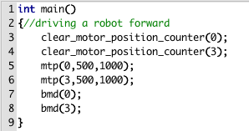

mav(port #, speed);

sleep(time in seconds);

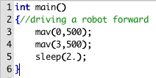

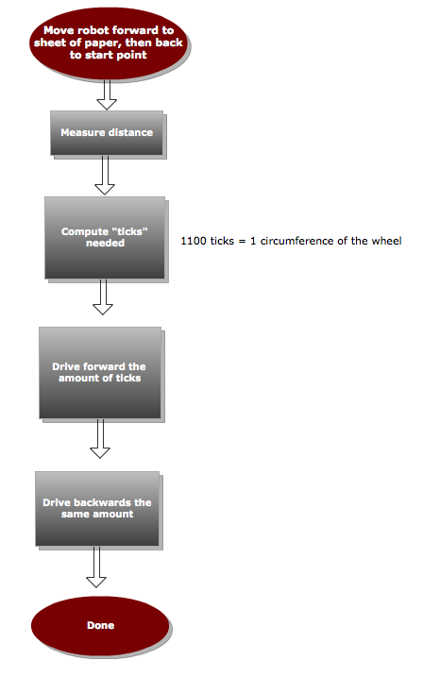 //driving a robot forward

int main() {//circumference = pi * d ,

int inches=12, ticks;//inches: distance to travel,

int d=2; d= diameter of wheel

ticks= (inches/(3.14159*d)*1100);

clear_motor_position_counter(0);

clear_motor_position_counter(3);

mtp(0,300,ticks);

mtp(3,300,ticks);

bmd(0);

bmd(3);

mtp(0,300,0);

mtp(3,300,0);

bmd(0);

bmd(3);

}

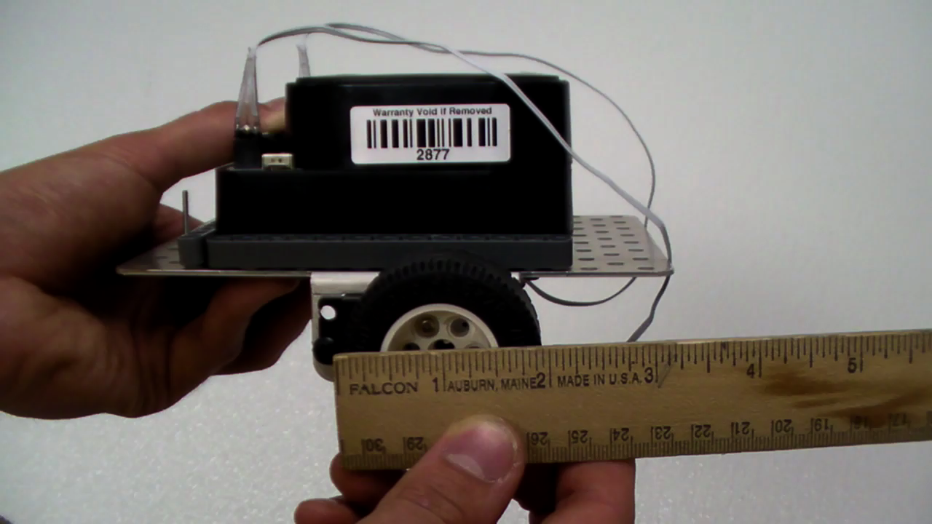

The diameter of the wheel is 2 inches.

The distance the wheel travels in one rotation is the circumference.

C = pi * d = 3.14 * 2 =6.28 inches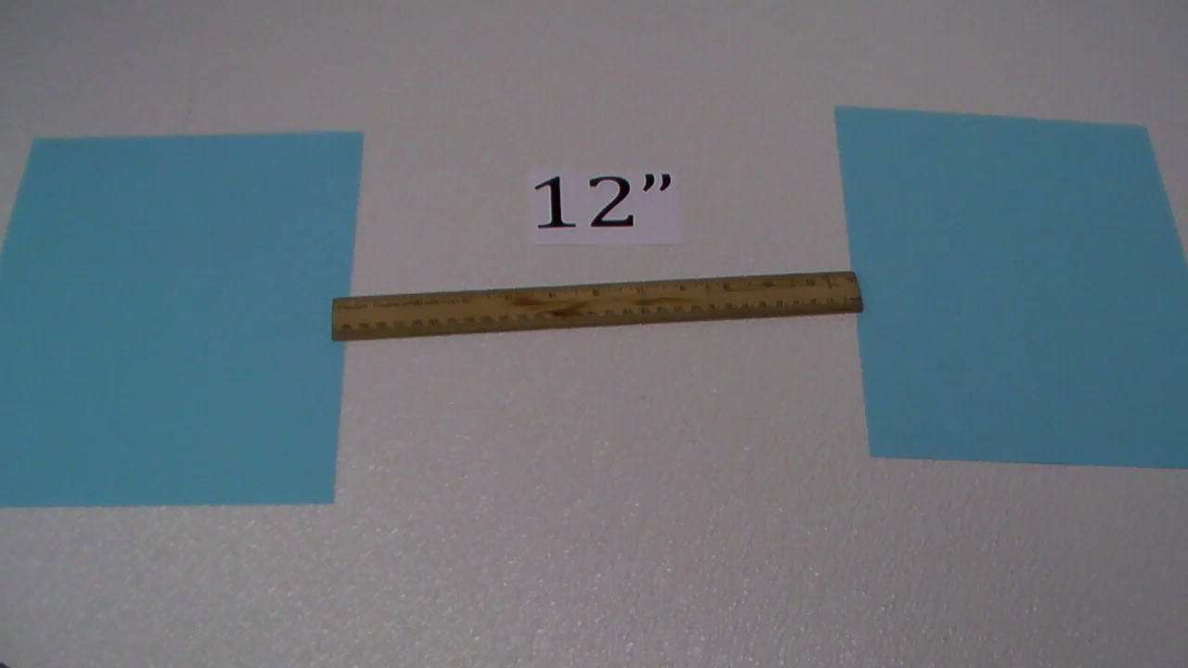

Dividing the distance to travel by the circumference determines how many rotations the wheel must turn.

12/6.28 = 1.91 rotations

multiply by 1100 ticks/rotation

=2102 ticks